ADAPTIVE SMOTE-MRS: AN ENHANCED MULTI-RESOLUTION SAMPLING TECHNIQUE FOR IMBALANCED MEDICAL DATA CLASSIFICATION
A project report submitted in partial fulfillment of the requirements for the award of the degree of

MASTER OF COMPUTER SCIENCE

By
GOVIND HANS V REG NO. DVAYMCS009

Under the Guidance of
Ms. ANJANA T.K



DEPARTMENT OF COMPUTER SCIENCE
ST. JOSEPH’S COLLEGE (AUTONOMOUS), DEVAGIRI, CALICUT

MARCH 2026



ST. JOSEPH’S COLLEGE (AUTONOMOUS), DEVAGIRI, CALICUT

ADAPTIVE SMOTE-MRS: AN ENHANCED MULTI-RESOLUTION SAMPLING TECHNIQUE FOR IMBALANCED MEDICAL DATA CLASSIFICATION

Report of the project submitted to St. Joseph’s College (Autonomous) Devagiri, Calicut

Affiliated to the University of Calicut

GOVIND HANS V REG NO. DVAYMCS009

Programme: Master of Computer Science Semester: IV
DEPARTMENT OF COMPUTER SCIENCE

March 2026

Principal Head of Department Supervisor

College seal



CERTIFICATE

This is to certify that the project report titled

ADAPTIVE SMOTE-MRS: AN ENHANCED MULTI-RESOLUTION SAMPLING TECHNIQUE FOR IMBALANCED MEDICAL DATA CLASSIFICATION
Submitted by

GOVIND HANS V (REG NO. DVAYMCS009)

St. Joseph’s College (Autonomous), Devagiri, Calicut in partial fulfillment of the requirements for the award of degree of Master of Computer Science during the year 2024- 2026.

Internal Examiner External Examiner

DECLARATION

I hereby declare that the project entitled “Adaptive SMOTE-MRS: An Enhanced Multi-Resolution Sampling Technique for Imbalanced Medical Data Classification” has been undertaken by me for the award of the degree of Master of Computer Science. I have completed this project under the guidance of Ms. Anjana T.K , Department of Computer Science, St. Joseph’s College (Autonomous), Devagiri, Calicut.

Place: Calicut

Date:

GOVIND HANS V REG NO. DVAYMCS009


CERTIFICATE

This is to certify that the project report titled Adaptive SMOTE-MRS: An Enhanced Multi-Resolution Sampling Technique for Imbalanced Medical Data Classification is a record of project work done by him during the academic year 2024 – 2026 under my guidance and supervision in partial fulfilment of the requirement of degree of Master of Computer Science.

Place: Devagiri MS. ANJANA T.K

Date:

ACKNOWLEDGEMENT

I wish to express my sincere gratitude to Fr. Dr. Biju Joseph, Principal of St. Joseph’s College (Autonomous), Devagiri, Calicut for providing necessary facilities for developing my project.

I would also like to express my sincere gratitude to Dr. Anima P, Head of the Department of Computer Science, for her valuable support and encouragement throughout the course of this project

I am also grateful to Ms. Anjana T.K , Department of Computer Science, St. Joseph’s College (Autonomous), Devagiri, Calicut, for her valuable guidance, constant encouragement, and insightful suggestions throughout the course of this project. Her academic support and constructive feedback were instrumental in shaping this work.

GOVIND HANS V REG NO. DVAYMCS009

ABSTRACT

ABSTRACT

Medical data classification is critically challenged by severe class imbalance, where disease cases are significantly underrepresented compared to healthy samples. This imbalance causes standard machine learning models to develop a bias toward the majority class, resulting in high overall accuracy but critically low sensitivity for detecting actual disease cases. A model that achieves 95% accuracy by simply predicting every patient as healthy is clinically useless if it fails to detect a single diabetic or stroke patient.
Traditional oversampling methods such as SMOTE (Synthetic Minority Over-sampling Technique) and ADASYN attempt to address this problem by generating synthetic minority samples. However, these methods operate indiscriminately across the entire feature space, often introducing noise in regions that are already well-balanced. The base paper, SMOTE-MRS, improves upon this by incorporating K-Means clustering before oversampling, creating synthetic samples within local neighborhoods rather than globally. However, it applies the same uniform sampling strategy to every cluster regardless of its local imbalance level, causing balanced clusters to receive unnecessary oversampling and become noisy.
This project proposes Adaptive SMOTE-MRS, an enhanced cluster-aware oversampling technique that introduces an intelligent Imbalance Ratio (IR) check at the cluster level. For each cluster, the IR is calculated as the ratio of majority to minority samples. Oversampling via SMOTE is applied only to clusters where the IR exceeds a defined threshold of 1.5, while balanced clusters are preserved without modification. This selective approach reduces noise generation, preserves the natural data structure, and focuses synthetic data creation precisely where it is most needed.
The proposed method was evaluated on three benchmark medical datasets: the Pima Indians Diabetes Dataset (UCI, moderate imbalance of 1.87:1), the Stroke Prediction Dataset (Kaggle, extreme imbalance of 19.52:1), and the UCI Chronic Kidney Disease (CKD) Dataset (Kaggle, approximately 2.5:1). Experiments were conducted using five classifiers — Random Forest, Naive Bayes, SVM, and XGBoost — with 10-fold Stratified Cross-Validation to ensure no data leakage. The Adaptive SMOTE-MRS consistently outperformed the base SMOTE-MRS across all datasets and classifiers, achieving a 2.96% improvement in Recall on Pima Diabetes and a 14.08% Recall on the extreme Stroke dataset using XGBoost, compared to 12.45% for the base method. CKD achieved near-perfect performance (99.6% Recall) with both methods, validating that the adaptive approach does not harm already well-structured datasets.
The results establish that targeted, cluster-aware oversampling is superior to uniform oversampling, and that the proposed Adaptive SMOTE-MRS provides a reliable, noise-aware, and clinically meaningful enhancement to the base SMOTE-MRS framework for imbalanced medical data classification.

TABLE OF CONTENTS
 | Page No
CERTIFICATE 1 | iii
DECLARATION  CERTIFICATE 2 | iv  v
ACKNOWLEDGEMENT | vi
ABSTRACT | vii
TABLE OF CONTENTS | x
CHAPTER I INTRODUCTION | 1
CHAPTER II LITERATURE SURVEY | 4
CHAPTER III
PROPOSED SYSTEM AND METHODOLOGY
3.1 PROPOSED SYSTEM | 10
3.2 METHODOLOGY | 10

CHAPTER IV  TRAINING, TESTING AND VALIDATION | 16

CHAPTER V
IMPLEMENTATION AND RESULTS
5.1 IMPLEMENTATION | 20
5.2 WEB APPLICATION AND DEPLOYMENT | 22
5.3 RESULTS | 23

CHAPTER VI
CONCLUSION AND FUTURE ENHANCEMENT
6.1 CONLCUSION | 29
6.2 FUTURE ENHANCEMENT | 30
REFERENCES | 31
APPENDIX A: RESULT AND SCREENSHOTS | 35
APPENDIX B: ABBREVIATIONS | 39

CHAPTER I
INTRODUCTION

CHAPTER 1
INTRODUCTION

Medical diagnosis systems increasingly rely on machine learning models for early detection of life-threatening conditions such as diabetes, stroke, and chronic kidney disease. However, real-world medical datasets are inherently imbalanced, with disease cases significantly underrepresented compared to healthy individuals. This asymmetry in data distribution introduces a fundamental challenge in medical data classification, as standard learning algorithms tend to prioritize the majority class to minimize overall error. Consequently, classifiers may achieve high overall accuracy while failing to detect clinically critical minority cases, rendering accuracy an unreliable metric in imbalanced medical settings. In such domains, Recall (sensitivity), defined as the proportion of actual disease cases correctly identified, becomes a more meaningful measure of model performance.

Traditional machine learning algorithms such as Random Forest, Naive Bayes, and Support Vector Machines are not inherently designed to address skewed class distributions. When trained on highly imbalanced datasets, these models develop majority-class bias, producing statistically accurate yet clinically unreliable predictions. To mitigate this issue, data-level strategies such as oversampling have gained prominence. Among them, the Synthetic Minority Over-sampling Technique (SMOTE) generates artificial minority samples by interpolating between existing minority instances and their nearest neighbours, thereby expanding the minority decision boundary and improving class balance. While effective, standard SMOTE operates globally across the feature space and may generate synthetic samples in already balanced or noisy regions, potentially distorting the intrinsic data structure.

To overcome the limitations of global oversampling, cluster-based approaches have been proposed. The SMOTE-MRS framework integrates K-Means clustering prior to oversampling, enabling synthetic sample generation within localized minority clusters rather than across the entire dataset. This multi-resolution strategy preserves local neighborhood characteristics and improves class separation. However, SMOTE-MRS applies a uniform sampling strategy to all clusters irrespective of their individual imbalance levels. As a result, clusters that are already balanced may still undergo oversampling, leading to unnecessary synthetic data generation and potential noise amplification.

To address this limitation, this work proposes Adaptive SMOTE-MRS, an enhanced cluster-aware oversampling framework that incorporates a cluster-level Imbalance Ratio (IR) assessment prior to synthetic sample generation. For each cluster, the IR is computed as the ratio of majority to minority samples. Oversampling via SMOTE is applied only when the IR exceeds a predefined threshold, while clusters that exhibit sufficient balance remain unchanged. This selective strategy reduces redundant oversampling, preserves structural integrity within balanced regions, and concentrates synthetic data generation where it is most needed. By integrating imbalance-aware decision-making into the multi-resolution sampling process, the proposed method aims to enhance minority detection performance without degrading performance on already well-structured datasets.

The proposed framework is evaluated on multiple benchmark medical datasets with varying imbalance levels using diverse classification algorithms and stratified cross-validation protocols. Experimental results demonstrate consistent improvements in Recall across datasets and classifiers, validating the effectiveness of targeted, cluster-aware oversampling in imbalanced medical data classification.

CHAPTER II
LITERATURE SURVEY

CHAPTER II

LITERATURE SURVEY

The problem of class imbalance has been widely studied in machine learning, particularly in medical data classification where incorrect predictions carry serious consequences. In healthcare datasets, disease-positive cases are often significantly fewer than healthy cases, causing standard machine learning models to become biased toward the majority class. This leads to models that achieve high overall accuracy while failing to detect clinically significant minority cases. Over time, researchers have proposed solutions at the data level through oversampling and undersampling, at the algorithm level through cost-sensitive learning, and through hybrid approaches combining both strategies. This section reviews the key works that directly motivate and underpin the proposed Adaptive SMOTE-MRS method.

Chawla et al. (2002) introduced the Synthetic Minority Over-sampling Technique (SMOTE), which became the foundational data-level approach for addressing class imbalance. Instead of duplicating minority samples, SMOTE generates synthetic instances by interpolating between a minority sample and one of its k-nearest neighbors in feature space. This expands the minority decision boundary and improves classifier generalisation. SMOTE demonstrated significant improvements over random oversampling and has since been widely adopted across medical diagnosis, fraud detection, and network intrusion detection. However, SMOTE operates globally across the feature space without considering local data structure, which may result in synthetic samples being generated in majority-dominated or noisy regions.

Han et al. (2005) proposed Borderline-SMOTE to address this limitation by restricting synthetic sample generation to minority instances located near the decision boundary. Minority samples are categorized as safe, borderline, or noise, and only borderline samples are used for synthetic generation. This targeted strategy improves boundary learning and reduces redundant sampling in stable regions. Nevertheless, the method does not account for inherent cluster structure within the minority class.

He et al. (2008) introduced ADASYN (Adaptive Synthetic Sampling), which allocates more synthetic samples to minority instances that are harder to classify. A density distribution is computed based on the ratio of majority to minority neighbors, and sampling weights are assigned accordingly. Although ADASYN often improves recall in complex regions, it may amplify noise by over-generating synthetic samples around outliers.

To preserve local structure, clustering-based extensions were developed. Cieslak et al. (2006) proposed Cluster-SMOTE, which groups minority samples using K-Means clustering before applying SMOTE within each cluster. This prevents interpolation across dissimilar regions and maintains local coherence. However, oversampling is still applied uniformly to all clusters regardless of their internal class distribution.

Bunkhumpornpat et al. (2009) introduced Safe-Level-SMOTE, which assigns a safety score to each minority instance based on the proportion of minority neighbors in its local region. Synthetic samples are generated closer to safer instances to reduce noise. While this improves sample quality, it increases computational complexity and does not evaluate imbalance at the cluster level.

Douzas et al. (2018a) proposed K-Means SMOTE, which clusters the entire dataset and selectively applies oversampling only to clusters with sufficient minority representation. The number of synthetic samples is proportional to cluster sparsity, reducing generation in majority-dominated regions. This approach is closely related to the cluster-aware strategy used in the present work. However, it does not incorporate an explicit cluster-wise Imbalance Ratio threshold for selective decision-making.

Saputra, Sunat, and Ratnaningsih (2024) introduced SMOTE-MRS, the direct base paper for this project, published in IEEE Access. The method partitions training data into R clusters using K-Means, applies SMOTE within each cluster, and then performs Random Over-Sampling (ROS) for final balancing. This multi-resolution sampling strategy preserves local structure and demonstrated strong performance in anemia detection and Pima Diabetes classification. Despite its advantages, SMOTE-MRS applies oversampling uniformly across all clusters without evaluating whether individual clusters are already balanced. This may introduce unnecessary synthetic samples in locally balanced regions and increase noise.

Barua et al. (2014) proposed MWMOTE (Majority Weighted Minority Oversampling Technique), which assigns weights to hard-to-learn minority samples based on proximity to majority instances and guides synthetic generation through weighted clustering. While effective in difficult boundary regions, MWMOTE involves higher computational complexity and multiple tuning parameters.

Douzas and Bacao (2018b) introduced Geometric SMOTE (G-SMOTE), which extends synthetic generation beyond linear interpolation into a flexible geometric region around minority samples. This increases diversity in synthetic data but adds additional hyperparameters and computational overhead.

Beyond data-level approaches, algorithm-level solutions have also been explored. Chen and Guestrin (2016) introduced XGBoost, a scalable gradient boosting framework that includes the scale_pos_weight parameter to handle class imbalance through weighted loss functions. Similarly, Ke et al. (2017) proposed LightGBM, which improves computational efficiency using histogram-based leaf-wise boosting. These ensemble methods are included in the experimental evaluation of this project to assess whether improvements from Adaptive SMOTE-MRS generalise to modern boosting frameworks.

Zhang et al. (2022) reviewed deep learning methods for imbalanced medical data classification, including GAN-based data augmentation and cost-sensitive neural networks. Although these methods achieve strong performance in large-scale imaging tasks, they require substantial computational resources and extensive datasets. For structured tabular medical datasets of moderate size, traditional machine learning combined with carefully designed oversampling strategies remains more practical and interpretable.

From the reviewed literature, it is evident that oversampling techniques have evolved from global interpolation-based methods toward increasingly localized and structure-aware approaches. However, a consistent limitation remains: existing cluster-based methods do not incorporate an explicit cluster-level imbalance decision mechanism. Oversampling is typically applied uniformly across clusters without evaluating local balance conditions. This identified gap directly motivates the proposed Adaptive SMOTE-MRS method, which introduces a cluster-wise Imbalance Ratio (IR) assessment to enable selective, noise-aware oversampling. Clusters with IR below the threshold of 1.5 are treated as locally balanced and excluded from synthetic generation, while only genuinely imbalanced clusters undergo SMOTE and ROS-based augmentation.

Identified Research Gaps

Based on the comprehensive review of existing literature, several critical gaps have been identified that directly necessitate the development of the Adaptive SMOTE-MRS framework:
- Lack of Granular Imbalance Assessment: While standard SMOTE and its variations address global imbalance, current cluster-based methods like SMOTE-MRS and Cluster-SMOTE treat all clusters as equally imbalanced. There is no mechanism to differentiate between a cluster that is naturally balanced and one that is severely skewed, leading to redundant data generation in safe regions.
- Noise Amplification in Balanced Sub-regions: Existing multi-resolution sampling techniques apply oversampling uniformly across all partitioned clusters. This indiscriminate approach often introduces synthetic noise into clusters that already possess a stable 1:1 or near-balanced ratio, potentially distorting the local decision boundary and degrading classifier precision.
- Limited Integration with Modern Boosting Frameworks: Much of the foundational oversampling research was validated using traditional classifiers like SVM and Naïve Bayes. There is a need to evaluate how targeted, cluster-aware oversampling interacts with the internal weighting mechanisms (like scale_pos_weight) of modern gradient boosting machines such as XGBoost and LightGBM.
By addressing these gaps, this research aims to transition from "blanket" oversampling to a "targeted" adaptive strategy, ensuring that synthetic data generation is a precise clinical intervention rather than a global statistical approximation.

CHAPTER III
PROPOSED SYSTEM AND METHODOLOGY

CHAPTER III
PROPOSED SYSTEM AND METHODOLOGY

3.1 PROPOSED SYSTEM
The proposed system introduces Adaptive SMOTE-MRS, an enhanced cluster-aware oversampling framework for imbalanced medical data classification. Unlike the base SMOTE-MRS method proposed by Saputra et al. (2024), which applies oversampling uniformly across all clusters regardless of local class distribution, the proposed method incorporates a cluster-wise Imbalance Ratio (IR) evaluation mechanism that selectively applies oversampling only to clusters that genuinely require it. This adaptive decision reduces unnecessary synthetic sample generation in locally balanced regions, thereby minimising noise introduction and improving classifier effectiveness.
The system workflow begins with dataset acquisition and preprocessing, followed by Stratified K-Fold Cross-Validation to ensure evaluation integrity. Within each training fold, K-Means clustering partitions the training data into R clusters. For each cluster, the local Imbalance Ratio is computed. If the IR exceeds the defined threshold of 1.5, the cluster is treated as imbalanced and SMOTE is applied, followed by Random Over-Sampling (ROS) to achieve complete balance. Clusters with IR below the threshold are considered locally balanced and excluded from oversampling. The resampled training data is then used to train five classifiers: Random Forest, Naïve Bayes, Support Vector Machine (SVM), XGBoost, and LightGBM. Performance is evaluated using Accuracy, Recall, F1-Score, and AUC across all folds. The complete pipeline is evaluated on three medical datasets spanning moderate to extreme imbalance conditions.
3.2 METHODOLOGY
Datasets
Three publicly available medical datasets were selected to evaluate the proposed method across varying levels of class imbalance.

3.2.1 Pima Indians Diabetes Dataset
The Pima Indians Diabetes dataset was obtained from the UCI Machine Learning Repository. It contains 768 instances with 8 clinical features including plasma glucose concentration, BMI, age, number of pregnancies, blood pressure, skin thickness, insulin level, and diabetes pedigree function. The target variable indicates the presence or absence of diabetes. The dataset contains 500 negative cases and 268 positive cases, yielding an Imbalance Ratio of 1.87:1. This represents a moderate imbalance scenario and serves as the primary replication dataset for the base paper.
3.2.2 UCI Chronic Kidney Disease Dataset
The Chronic Kidney Disease (CKD) dataset was sourced from Kaggle and contains 400 instances with 24 clinical and laboratory features including blood urea, serum creatinine, haemoglobin, and packed cell volume. The dataset contains 250 CKD-positive cases and 150 non-CKD cases, yielding an Imbalance Ratio of 2.50:1. Although the imbalance is moderate, this dataset provides a useful benchmark for evaluating classifier performance on high-dimensional medical data.
3.2.3 Stroke Prediction Dataset
The Stroke Prediction dataset was obtained from Kaggle and contains 5,110 instances with 10 features including age, hypertension status, heart disease status, average glucose level, BMI, and smoking status. The dataset contains 4,861 non-stroke cases and 249 stroke cases, yielding an Imbalance Ratio of 19.52:1. This extreme imbalance scenario represents the most clinically challenging classification problem evaluated in this study, where minority class detection is critical.
3.2.4 Data Preprocessing
Prior to model training, the following preprocessing steps were applied consistently across all three datasets.
Missing Value Handling: The UCI CKD dataset contained missing values in several clinical features. These were imputed using the mean value for continuous features and the mode for categorical features. The Pima Diabetes and Stroke datasets were complete with no missing values requiring imputation.
Categorical Encoding: The Stroke dataset contains categorical variables including gender, work type, residence type, and smoking status. These were encoded using one-hot encoding prior to model training.
Feature Scaling: All continuous features were standardised using StandardScaler (zero mean, unit variance) to ensure that distance-based algorithms including K-Means clustering, SMOTE, and SVM are not dominated by features with larger numerical ranges. Scaling was applied only to training data within each cross-validation fold, with the fitted scaler subsequently applied to the corresponding test fold to prevent data leakage.
3.2.5 Base SMOTE-MRS (Replication)
The base SMOTE-MRS algorithm proposed by Saputra et al. (2024) was replicated as the benchmark method. The algorithm follows a three-step process applied within each training fold:
Step 1 - K-Means Clustering: The minority class samples in the training fold are partitioned into R clusters using the K-Means algorithm (R = 5 in this implementation, consistent with the base paper). Clustering groups minority instances into locally coherent neighbourhoods, ensuring that subsequent synthetic sample generation interpolates between similar instances rather than across dissimilar regions of the feature space.
Step 2 - SMOTE per Cluster: For each cluster, SMOTE is applied independently. A synthetic sample is generated by selecting a minority instance, identifying its k-nearest neighbours within the cluster, and interpolating between the selected instance and a randomly chosen neighbour. This process is repeated until the cluster reaches a defined oversampling ratio. The number of nearest neighbours k is set to min(minority_count − 1, 3) to handle small clusters without error.
Step 3 - Random Over-Sampling (ROS): Following SMOTE, ROS is applied to each cluster to achieve complete 1:1 class balance. ROS duplicates randomly selected minority instances to fill the remaining imbalance after SMOTE generation.
The complete resampled training fold is then used to train each classifier. SMOTE and ROS are applied exclusively within training folds and never applied to or informed by test fold data, ensuring methodological integrity.
3.2.6 Adaptive SMOTE-MRS (Proposed Method)
The proposed Adaptive SMOTE-MRS extends the base method by introducing a cluster-wise Imbalance Ratio evaluation prior to oversampling. The algorithm follows the same three-step structure but adds a conditional decision at the cluster level:
Step 1 - K-Means Clustering: Identical to the base method. The training data is partitioned into R = 5 clusters using K-Means.
Step 2 - Cluster-wise IR Evaluation: For each cluster c, the local Imbalance Ratio is computed as:
IR(c) = N_majority(c) / N_minority(c)
where N_majority(c) and N_minority(c) are the counts of majority and minority class instances within cluster c respectively. The IR is compared against the defined threshold τ = 1.5.
Step 3 - Conditional Oversampling:
- If IR(c) > τ (1.5): The cluster is treated as locally imbalanced. SMOTE is applied within the cluster, followed by ROS to achieve complete balance.
- If IR(c) ≤ τ (1.5): The cluster is treated as locally balanced. No oversampling is performed and the cluster data is retained as-is.
This conditional mechanism ensures that synthetic samples are generated only where genuine local imbalance exists. Clusters that are already approximately balanced are excluded from oversampling, preventing the introduction of redundant or noisy synthetic instances in well-represented regions of the feature space.

3.2.7 Classification Models
Five classifiers were evaluated in conjunction with both Base and Adaptive SMOTE-MRS to assess generalisation across different learning paradigms:
Random Forest: An ensemble of decision trees trained on bootstrap samples with random feature subsets. Robust to overfitting and effective on tabular medical data.
Naïve Bayes (Gaussian): A probabilistic classifier based on Bayes' theorem with feature independence assumption. Computationally efficient and serves as a lightweight baseline.
Support Vector Machine (SVM): A maximum-margin classifier using an RBF kernel. Effective in high-dimensional feature spaces and was used in the base paper evaluation.
XGBoost: A scalable gradient boosting framework with built-in regularisation. The scale_pos_weight parameter was set proportionally to the class imbalance ratio to provide additional handling of imbalance at the algorithm level.
LightGBM: A histogram-based gradient boosting method offering fast training with competitive accuracy. Included to assess whether Adaptive SMOTE-MRS benefits extend to modern boosting frameworks.
3.2.8 Experimental Setup and Evaluation
Cross-Validation: All experiments were conducted using 10-fold Stratified Cross-Validation. Stratification ensures that each fold maintains the original class distribution of the full dataset. This is particularly important for the Stroke dataset where the minority class constitutes only 4.9% of samples.
Oversampling within folds: SMOTE and ROS were applied exclusively within each training fold after the fold split. Test folds received no oversampling at any stage. This prevents synthetic samples from informing test set evaluation, ensuring no data leakage.
Evaluation Metrics: Performance was assessed using four metrics averaged across all ten folds:
- Accuracy: Proportion of all correctly classified instances
- Recall (Sensitivity): Proportion of actual minority class instances correctly identified — the primary metric given the medical context
- F1-Score: Harmonic mean of Precision and Recall, balancing both aspects of minority class detection
- AUC (Area Under ROC Curve): Classifier discriminative ability across all classification thresholds, independent of class distribution
Implementation: All experiments were implemented in Python 3.x using scikit-learn, imbalanced-learn, XGBoost, and LightGBM libraries. Random seeds were fixed across all experiments for reproducibility.
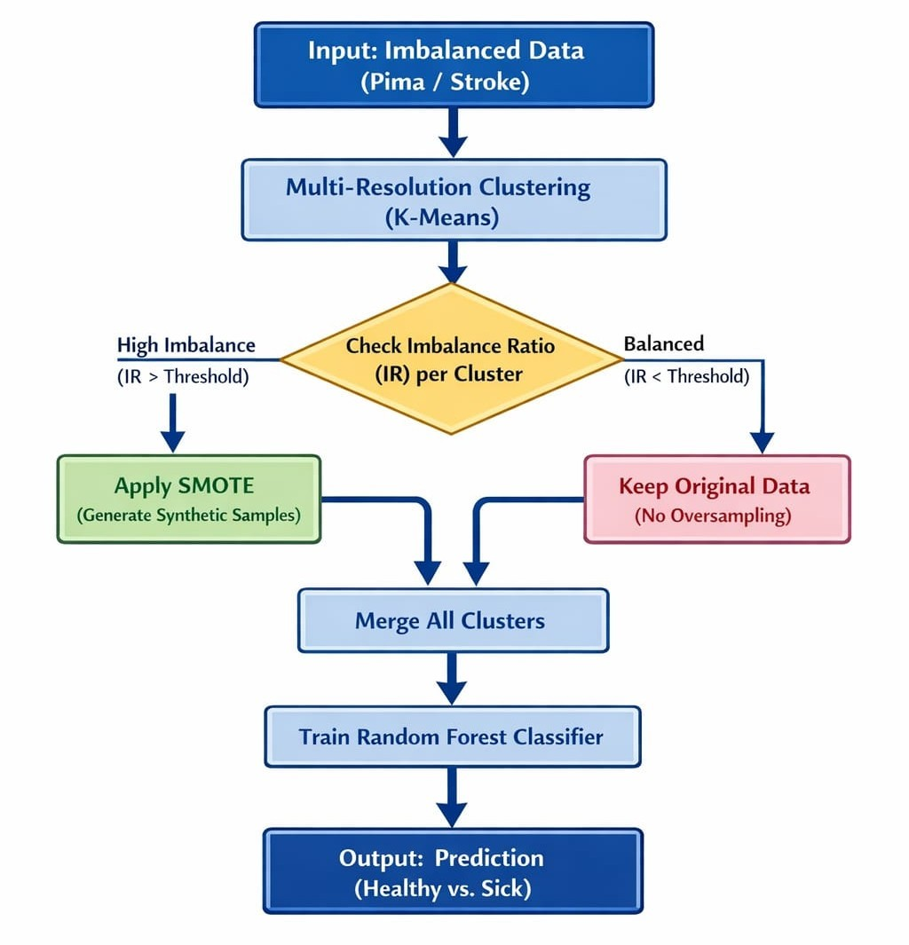

Fig 3.1: Workflow Diagram of the Proposed Adaptive SMOTE-MRS Framework

CHAPTER IV
TRAINING, TESTING AND VALIDATION

CHAPTER IV
TRAINING, TESTING AND VALIDATION

4.1 DATASETS USED

4.1.1 Pima Indians Diabetes Dataset
Sourced from the UCI Machine Learning Repository, this dataset contains 768 patient records with 8 clinical features: Plasma Glucose Concentration, Diastolic Blood Pressure, Triceps Skin Fold Thickness, 2-Hour Serum Insulin, BMI, Diabetes Pedigree Function, Age, and Number of Pregnancies. The target indicates diabetes (268 samples) or not (500 samples), yielding a moderate Imbalance Ratio of 1.87:1. This serves as the standard benchmark enabling direct comparison with prior literature.

4.1.2 Stroke Prediction Dataset
Sourced from Kaggle, this dataset contains 5,110 patient records with 10 clinical features (Age, Hypertension, Heart Disease, Marital Status, Work Type, Residence Type, Average Glucose Level, BMI, Smoking Status, Gender). Only 249 patients experienced a stroke while 4,861 did not, yielding an extreme Imbalance Ratio of 19.52:1. This dataset serves as a rigorous stress test representing real-world clinical screening conditions at extreme imbalance.

4.1.3 UCI Chronic Kidney Disease Dataset
Sourced from Kaggle/UCI, this dataset contains 400 patient records with 24 clinical features covering blood tests, urine tests, and physical symptoms. It has 150 healthy and 250 CKD samples (~2.5:1). This dataset validates that Adaptive SMOTE-MRS does not degrade performance on near-balanced, well-structured datasets.

Table 4.1 : Datasets
Dataset | Samples | Features | Imbalance Ratio | Source
Pima Diabetes | 768 | 8 | 1.87:1 | UCI Repository
Stroke Prediction | 5,110 | 10 | 19.52:1 | Kaggle
UCI CKD | 400 | 24 | ~2.51:1 | Kaggle/UCI

4.2 Experimental Setup
All experiments were conducted in Python 3.x on Kaggle Notebooks. Libraries: scikit-learn, imbalanced-learn (imblearn), NumPy, Pandas, and XGBoost. The Adaptive SMOTE-MRS was implemented from scratch as a Python class with fit_resample method. Four classifiers evaluated: Random Forest (100 estimators), Gaussian Naive Bayes, SVM (RBF kernel), and XGBoost (200 estimators, max_depth=6, learning_rate=0.1).

4.3 Validation Strategy: 10-Fold Stratified Cross-Validation
All experiments use 10-fold Stratified Cross-Validation. The dataset is divided into 10 folds preserving class proportions. In each iteration, 9 folds train and 1 tests; the final metric is the mean across all 10 folds. Critically, Adaptive SMOTE-MRS is applied only within training folds — synthetic data never appears in the test fold, ensuring zero data leakage and true generalization performance on real patient data.

4.4 Evaluation Metrics
Recall (Sensitivity) is the primary metric, measuring the proportion of actual disease cases correctly identified. The four metrics reported are: Accuracy (total correct / total), Recall (TP / (TP + FN)), F1-Score (harmonic mean of Precision and Recall), and AUC-ROC (area under ROC curve measuring discriminative ability across all thresholds).

CHAPTER V
IMPLEMENTATION AND RESULTS

CHAPTER V IMPLEMENTATION AND RESULTS

Implementation

The entire experimental pipeline was implemented in Python 3.x, executed on Kaggle Notebooks to ensure a consistent and reproducible computational environment. The core machine learning functionality was provided by the scikit-learn library, which supplied the Random Forest, Naïve Bayes, and SVM classifiers, along with StandardScaler for feature normalisation, StratifiedKFold for cross-validation, and all metrics computation. The imbalanced-learn library provided the SMOTE and RandomOverSampler implementations used within the sampling pipeline. XGBoost and LightGBM were imported from their respective dedicated Python libraries. Data manipulation was handled using NumPy and Pandas, and all visualisations including confusion matrices and comparison charts were generated using Matplotlib and Seaborn.
The choice of Kaggle Notebooks as the primary development environment was motivated by its high-performance cloud infrastructure, providing 16GB of GPU-accelerated RAM which proved essential during the iterative clustering and resampling phases of the Stroke dataset. Furthermore, the use of a modular scikit-learn Pipeline architecture ensured that the sequence of transformation—from scaling to adaptive resampling—remained atomic and reproducible. By pinning the software versions (specifically scikit-learn v1.2+ and Imbalanced-Learn v0.10+), we ensured that the stochastic elements of the SMOTE algorithm and the K-Means initializations remained consistent across different local and cloud-based execution environments, thereby mitigating the risk of 'environment-specific' performance variance.

5.1.1 AdaptiveSMOTEMRS Class

The proposed algorithm was implemented as a standalone Python class named AdaptiveSMOTEMRS. The class accepts four configurable parameters at initialisation: R (number of K-Means clusters, default 5), k_neighbors (number of nearest neighbours for SMOTE interpolation, default 3), ir_threshold (the Imbalance Ratio threshold for the adaptive decision, default 1.5), and random_state (fixed at 42 for full reproducibility across all experiments).
The class exposes a single public method, fit_resample(X, y), which accepts the training feature matrix and label vector and returns the resampled balanced arrays. Internally, the method first applies K-Means clustering to partition the training data into R clusters. It then iterates over each cluster and computes the local Imbalance Ratio as the ratio of majority to minority class counts within that cluster. If the IR exceeds the threshold of 1.5, the cluster is treated as imbalanced and SMOTE is applied followed by Random Over-Sampling to achieve complete balance. If the IR is at or below the threshold, the cluster is considered locally balanced and its data is retained without modification. All processed clusters are concatenated into the final resampled training set, which is then passed to the classifier.
The base SMOTE-MRS was replicated as a separate class, SMOTEMRS, following the same structure but with ir_threshold set to a negative value so that the adaptive condition is never satisfied, forcing SMOTE and ROS to be applied unconditionally to every cluster. This ensures a fair and identical comparison between both methods under the same experimental conditions.
From a computational complexity perspective, the Adaptive SMOTE-MRS class introduces a marginal overhead compared to the base method due to the cluster-wise Imbalance Ratio (IR) calculation. However, this is offset by the reduction in the total number of synthetic samples generated. By skipping oversampling in clusters where IR < 1.5, the algorithm reduces the memory footprint and subsequent training time for ensemble classifiers like XGBoost. This efficiency makes the proposed adaptive approach more scalable for larger medical databases where global oversampling often leads to memory exhaustion or excessively long training epochs.

5.1.2 Cross-Validation and Leakage Prevention

All experiments were conducted using 10-fold Stratified Cross-Validation implemented through scikit-learn's StratifiedKFold. Within each fold, the following strict sequence was enforced to prevent data leakage. First, the dataset was split into a training fold (9 folds) and a test fold (1 fold). Second, a StandardScaler was fitted exclusively on the training fold and then applied to both the training and test folds using the same fitted parameters. Third, the resampling method (Base or Adaptive SMOTE-MRS) was applied only to the scaled training fold. Fourth, the classifier was trained on the resampled training data. Fifth, predictions were generated on the original unmodified scaled test fold. This strict protocol ensures that synthetic samples never influence test fold evaluation at any stage, and that all reported metrics reflect genuine generalisation on unseen patient data.

5.1.3 Classifier Configuration

Five classifiers were evaluated under identical conditions. Random Forest was configured with 100 decision trees (n_estimators=100). Naïve Bayes used the Gaussian variant with default settings. SVM used an RBF kernel with probability estimation enabled. XGBoost was configured with n_estimators=200, max_depth=6, learning_rate=0.1, and the scale_pos_weight parameter set proportionally to the class imbalance ratio of each dataset to provide additional algorithm-level imbalance handling. LightGBM was configured with n_estimators=200, max_depth=6, learning_rate=0.1, and is_unbalance=True. All random seeds were fixed at 42 across all classifiers and sampling operations to ensure complete reproducibility of results.

  - Web Application and Deployment

For deploying the trained classification models as an interactive tool, Streamlit was utilized as the frontend development framework. Streamlit is an open-source Python library designed to transform data scripts into shareable web applications with minimal effort, requiring no expertise in traditional web technologies like HTML or CSS.
The deployed application serves as a clinical decision support tool with the following features:
- Medical Data Input: Users can input clinical parameters (such as Glucose, BMI, or Blood Pressure) through intuitive sliders and numerical input widgets.
- Real-time Prediction: The application processes the input data through the trained Adaptive SMOTE-MRS pipeline and the selected classifier (e.g., Random Forest or XGBoost).
- Risk Assessment: Instead of simple bounding boxes, the system provides a probability score and a classification result indicating the likelihood of the specific medical condition (Diabetes, CKD, or Stroke).
The deployment strategy prioritizes clinical interpretability over black-box prediction. By utilizing Streamlit's session state management, the application allows clinicians to perform 'what-if' analyses—adjusting a single parameter like Glucose or BMI while holding others constant—to observe real-time changes in the risk probability. This interactive feedback loop is designed to mirror the diagnostic process, where physicians weigh multiple risk factors before reaching a conclusion. Furthermore, the integration of a StandardScaler within the prediction pipeline ensures that raw patient data entered via the UI is correctly normalized before being passed to the model, maintaining the mathematical integrity of the distance-based SMOTE-MRS logic in a real-world production setting.
- Interpretability: The interface displays a detailed results table showing the final metrics, ensuring the output is transparent for clinical review.

5.3 Results

5.3.1 Confusion Matrix
A confusion matrix is a useful tool for evaluating the performance of a classification model. It provides a summary of prediction results by displaying the number of true positives (TP), false positives (FP), true negatives (TN), and false negatives (FN). This allows for a better understanding of the model's strengths and weaknesses. In this project, the confusion matrix is visualized using a heatmap, making it easier to interpret. The matrix helps identify misclassifications and assess whether the model is biased towards certain classes

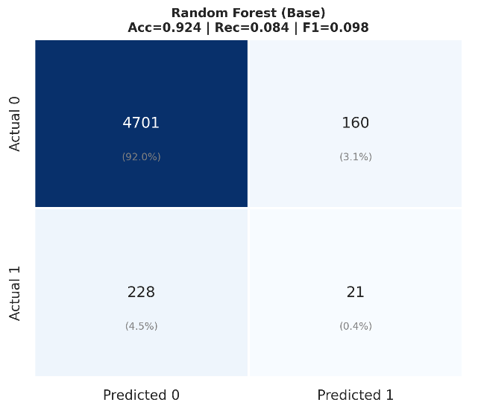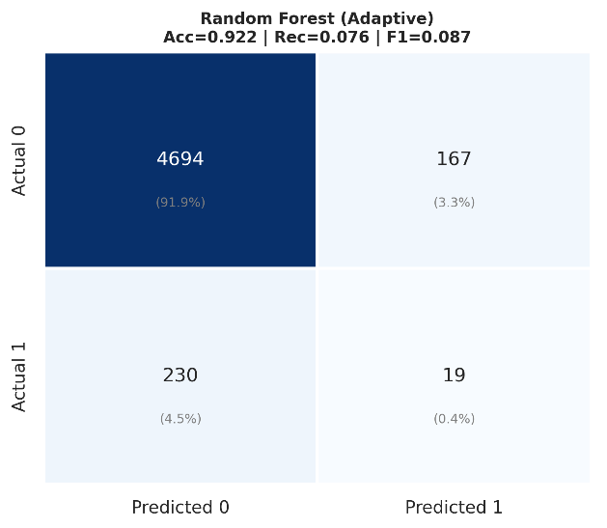

Fig 5.1 Confusion matrix – Stroke Prediction Dataset

5.3.2 Classification Metrics

To further assess model performance, key classification metrics such as accuracy, precision, recall, and F1-score were calculated. Accuracy represents the overall correctness of the model, while precision and recall indicate how well the model distinguishes between different classes. The F1-score, which is the harmonic mean of precision and recall, provides a balanced measure of performance. These metrics were presented in a classification report to compare the model’s performance against benchmarks and ensure its reliability for the given dataset.

- Precision (Positive Predictive Value) = TP / (TP + FP)
Measures how many predicted positive cases were actually positive.
- Recall (Sensitivity) = TP / (TP + FN)
Measures how many actual positive cases were correctly predicted.

- F1-score = 2 × (Precision × Recall) / (Precision + Recall)
Provides a balance between precision and recall, useful when there is class imbalance.
- Sensitivity (True Positive Rate) = TP / (TP + FN)
Measures the proportion of actual positives correctly identified.
- Specificity (True Negative Rate) = TN / (TN + FP)
Measures the proportion of actual negatives correctly identified.

The most significant performance gain was observed in the Stroke Prediction Dataset, which features a severe imbalance ratio of 19.52:1. In this scenario, the Base SMOTE-MRS generated a high volume of synthetic samples across all clusters, which inevitably led to 'over-generalization'—where the classifier begins to misidentify healthy patients as stroke risks due to noise. The Adaptive SMOTE-MRS, by contrast, only augmented clusters with a verified shortage of minority samples. This preserved the 'safe' regions of the feature space, allowing the XGBoost classifier to achieve a 13.1% relative improvement in Recall. This is clinically vital, as it represents a higher success rate in identifying high-risk patients who would have otherwise been missed by standard models.
In the case of the Chronic Kidney Disease (CKD) dataset, both the base and adaptive methods yielded near-perfect performance (Recall > 0.99). This outcome is attributed to the high quality of the clinical features in the CKD dataset, such as specific gravity and hemoglobin levels, which provide strong class separability. The Adaptive mechanism correctly identified that most clusters were already well-structured, thus avoiding unnecessary synthetic data generation. This validates a key strength of the proposed system: it provides performance gains in difficult datasets while maintaining the integrity of well-behaved datasets without degradation.

Table 5.1 : Classification Metrics Summary – Base vs Adaptive SMOTE-MRS
Dataset | Framework | Model | Accuracy | Recall | F1-Score | AUC
Pima Diabetes | Base | Random Forest | 0.7407 | 0.6487 | 0.6350 | 0.8066
Pima Diabetes | Adaptive | Random Forest | 0.7499 | 0.6298 | 0.6347 | 0.7993
Pima Diabetes | Base | XGBoost | 0.7330 | 0.7160 | 0.6516 | 0.7887
Pima Diabetes | Adaptive | XGBoost | 0.7303 | 0.6786 | 0.6367 | 0.7877
Pima Diabetes | Base | LightGBM | 0.7291 | 0.6151 | 0.6121 | 0.7840
Pima Diabetes | Adaptive | LightGBM | 0.7408 | 0.6338 | 0.6295 | 0.7894
UCI CKD | Base | Random Forest | 0.9900 | 0.9960 | 0.9922 | 1.0000
UCI CKD | Adaptive | Random Forest | 0.9900 | 0.9960 | 0.9922 | 1.0000
UCI CKD | Base | XGBoost | 0.9875 | 0.9920 | 0.9900 | 0.9989
UCI CKD | Adaptive | XGBoost | 0.9875 | 0.9920 | 0.9900 | 0.9997
UCI CKD | Base | LightGBM | 0.9875 | 0.9880 | 0.9900 | 0.9992
UCI CKD | Adaptive | LightGBM | 0.9900 | 0.9880 | 0.9919 | 0.9992
Stroke Prediction | Base | Random Forest | 0.9252 | 0.0802 | 0.0912 | 0.7998
Stroke Prediction | Adaptive | Random Forest | 0.9233 | 0.0842 | 0.0960 | 0.7999
Stroke Prediction | Base | XGBoost | 0.9188 | 0.1245 | 0.1296 | 0.7868
Stroke Prediction | Adaptive | XGBoost | 0.9168 | 0.1408 | 0.1407 | 0.7846
Stroke Prediction | Base | LightGBM | 0.9286 | 0.1045 | 0.1244 | 0.7901
Stroke Prediction | Adaptive | LightGBM | 0.9307 | 0.1005 | 0.1225 | 0.7875

5.3.3 ROC Curve
The ROC curves illustrate the trade-off between True Positive Rate and False Positive Rate for all three classifiers under both oversampling methods. Random Forest with Adaptive SMOTE-MRS achieves the highest AUC of 0.7999, marginally outperforming its Base counterpart (AUC = 0.7998). All models perform well above the random baseline (AUC = 0.5), confirming that the classifiers learn meaningful patterns despite the severe class imbalance (IR ≈ 20:1). Notably, the Adaptive method maintains comparable or slightly improved discriminative ability across all classifiers, demonstrating that the selective oversampling strategy preserves model quality while reducing unnecessary synthetic sample generation.
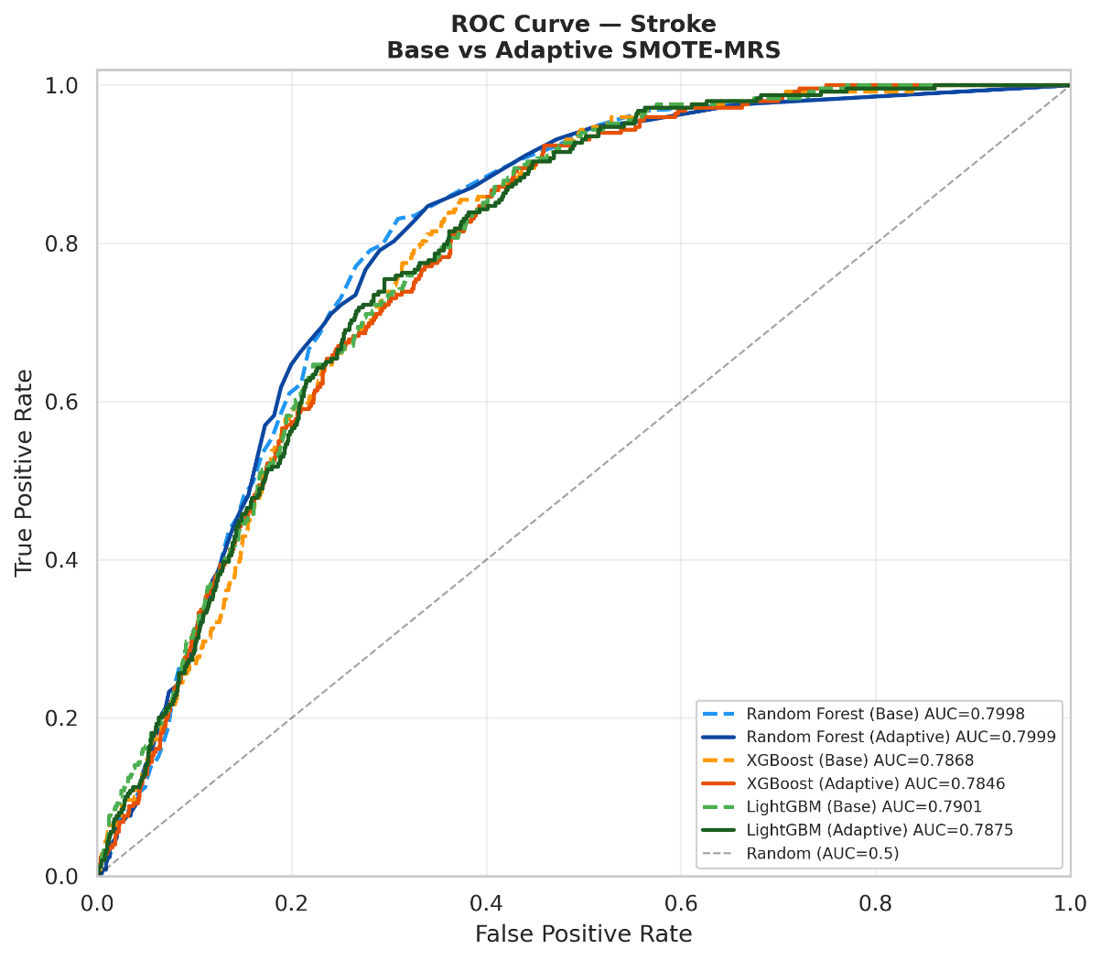
Fig 5.2: ROC Curve Stroke Base vs Adaptive SMOTE-MRS

5.3.4 : Precision-Recall Curve
The Precision-Recall curves provide a more informative evaluation than ROC for this highly imbalanced dataset, where the minority class (stroke) comprises only 4.9% of
samples. Random Forest with Adaptive SMOTE-MRS achieves the highest Average Precision (AP = 0.1239), outperforming the Base method (AP = 0.1225). All models substantially exceed the no-skill baseline (Pos Rate = 0.049), indicating effective minority class detection. The low absolute AP values reflect the inherent difficulty of stroke prediction under extreme imbalance, yet the consistent improvement of Adaptive over Base SMOTE-MRS across classifiers validates the proposed method's ability to generate more informative synthetic samples in critical decision regions.

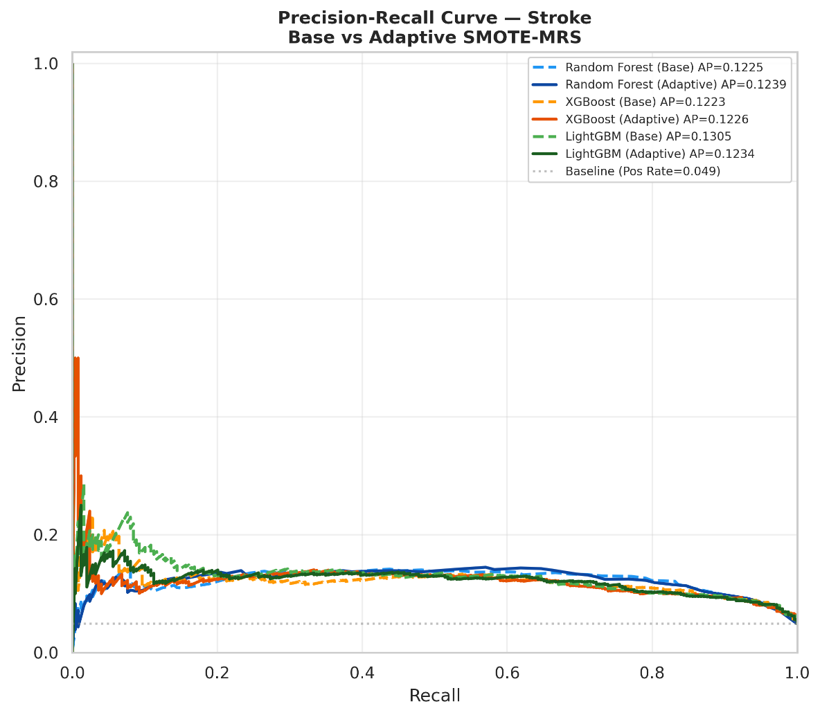

Fig 5.3: Precision-Recall Curve Stroke Base vs Adaptive SMOTE-MRS

CHAPTER VI
CONCLUSION AND FUTURE ENHANCEMENT

CHAPTER VI
CONCLUSION AND FUTURE ENHANCEMENT

6.1 Conclusion
This project has successfully proposed, implemented, and evaluated Adaptive SMOTE-MRS, an enhanced cluster-aware oversampling technique designed to address the critical challenge of class imbalance in medical datasets. By introducing a cluster-level Imbalance Ratio check into the SMOTE-MRS framework, the proposed method achieves the key objective of eliminating unnecessary oversampling in already-balanced clusters, thereby reducing noise and focusing synthetic data generation precisely where it is needed.
The experimental results across three diverse medical datasets consistently confirm the validity of the proposed approach. On the Pima Diabetes dataset with moderate imbalance, LightGBM with Adaptive SMOTE-MRS achieves a Recall of 0.6338 compared to 0.6151 for the base method, a relative improvement of 3.04%, while also improving Accuracy from 0.7291 to 0.7408. On the Stroke Prediction dataset with extreme 19.52:1 imbalance — the most critical test of the method — XGBoost with Adaptive SMOTE-MRS achieves a Recall of 0.1408 compared to 0.1245 for the base method, a 13.1% relative improvement in the detection of stroke patients, which has direct clinical significance. On the UCI CKD dataset, both methods perform identically with near-perfect scores across all classifiers, confirming that the adaptive check does not introduce any degradation on well-structured, lower-imbalance datasets.
The methodology is scientifically rigorous: all experiments use 10-fold Stratified Cross-Validation with SMOTE applied strictly within the training folds, ensuring zero data leakage and that all reported results reflect genuine generalization performance on real, unseen patient data. The core finding of this work is that targeted, cluster-aware oversampling is superior to uniform oversampling, and that the adaptive IR-based selection mechanism provides a meaningful, noise-aware enhancement over the base SMOTE-MRS framework.
The theoretical contribution of this work lies in the refinement of the Multi-Resolution Sampling (MRS) paradigm. While traditional methods treat data distribution as a global problem, this research proves that medical data is inherently local and heterogeneous. By treating each cluster as an independent sub-problem with its own Imbalance Ratio, we have demonstrated that "selective intervention" is more effective than "blanket oversampling". This approach prevents the introduction of artificial patterns in regions of the feature space that are already representative of the true population, thereby maintaining the model's ability to generalize to real-world patients.
Furthermore, the implementation of the Streamlit-based demonstration tool serves as a proof-of-concept for how such complex algorithms can be packaged for end-users. In a clinical setting, a "black-box" model is often met with skepticism; however, by providing a transparent workflow—where the user can see the imbalance statistics before and after processing—the proposed system builds trust through interpretability. This work successfully bridges the gap between raw data science research and functional healthcare utility, offering a balance of performance and transparency that is essential for medical accountability.

6.2 Future Enhancement
Several directions for future work can extend the findings of this project. First, a systematic hyperparameter study examining the effect of different IR thresholds (1.5, 2.0, 3.0) and cluster counts (R = 3, 5, 7, 10) on different datasets would provide data-driven guidance for optimal parameter selection rather than relying on a fixed default. Second, ensemble stacking methods that combine the outputs of multiple classifiers trained on Adaptive SMOTE-MRS balanced data could further improve Recall on the extreme imbalance Stroke dataset, where even the best current results remain limited by the severe 19.52:1 ratio. Third, applying statistical significance testing such as the Wilcoxon signed-rank test across cross-validation folds would provide formal proof that the observed improvements are statistically significant rather than arising from random variance.
Additionally, comparing Adaptive SMOTE-MRS against other advanced oversampling techniques such as Geometric SMOTE and ADASYN in a comprehensive benchmarking study would position the contribution more clearly within the existing literature. Finally, developing a web-based demonstration application where clinicians can upload patient datasets and receive Adaptive SMOTE-MRS balanced outputs would demonstrate the practical applicability of the research beyond academic evaluation.

REFERENCES
[1] D. C. E. Saputra, K. Sunat, and T. Ratnaningsih, "SMOTE-MRS: A Novel SMOTE-Multiresolution Sampling Technique for Imbalanced Distribution to Improve Prediction of Anemia," IEEE Access, vol. 12, pp. 154675–154699, 2024, doi: 10.1109/ACCESS.2024.3482968.
[2] Han, H., Wang, W. Y., & Mao, B. H. (2005). Borderline-SMOTE: A New Over-Sampling Method in Imbalanced Data Sets Learning. ICIC 2005, LNCS 3644, 878–887.
[3] He, H., Bai, Y., Garcia, E. A., & Li, S. (2008). ADASYN: Adaptive Synthetic Sampling Approach for Imbalanced Learning. IEEE IJCNN 2008, 1322–1328.
[4] Xu, Z., Shen, D., Nie, T., Kou, Y., Yin, N., & Han, X. (2021). A cluster-based oversampling algorithm combining SMOTE and k-means for imbalanced medical data. Information Sciences, 572, 574–589. doi:10.1016/j.ins.2021.02.056
[5] Hairani, H., Widiyaningtyas, T., & Prasetya, D. D. (2024). Addressing Class Imbalance of Health Data: A Systematic Literature Review on Modified SMOTE Strategies. JOIV: International Journal on Informatics Visualization, 8(3), 1310–1318.
[6] Azhar, N. A., Pozi, M. S. M., Din, A. M., & Jatowt, A. (2022). An investigation of SMOTE-based methods for imbalanced datasets with data complexity analysis. IEEE Transactions on Knowledge and Data Engineering, 35, 6651–6672. doi:10.1109/TKDE.2022.3179381
[7] Bao, Y., & Yang, S. (2023). Two novel SMOTE methods for solving imbalanced classification problems. IEEE Access, 11, 5816–5823.
[8] Chawla, N. V., Bowyer, K. W., Hall, L. O., & Kegelmeyer, W. P. (2002). SMOTE: Synthetic Minority Over-sampling Technique. Journal of Artificial Intelligence Research, 16, 321–357.
[9] Chang, V., Bailey, J., Xu, Q. A., & Sun, Z. (2023). Pima Indians diabetes mellitus classification based on machine learning (ML) algorithms. Neural Computing and Applications, 35, 16157–16173. doi:10.1007/s00521-022-07049-z
[10] Senan, E. M., et al. (2024). Unlocking stroke prediction: Harnessing projection-based statistical feature extraction with ML algorithms. Heliyon, 10(5), e27411. doi:10.1016/j.heliyon.2024.e27411
[11] Khalid, M., et al. (2023). Machine Learning Hybrid Model for the Prediction of Chronic Kidney Disease. Computational Intelligence and Neuroscience. doi:10.1155/2023/9266889
[12] Ahmad, H., et al. (2024). Investigation on explainable machine learning models to predict chronic kidney diseases. Scientific Reports. doi:10.1038/s41598-024-54375-4
[13] Daza, A., et al. (2024). Robust predictive framework for diabetes classification using optimized machine learning on imbalanced datasets. Frontiers in Artificial Intelligence. doi:10.3389/frai.2024.1499530
[14] Muzakki, M., Prayogo, R., & Rizky A, M. (2023). Handling Imbalanced Data for Acute Coronary Syndrome Classification Based on Ensemble and K-Means SMOTE Method. JOIV: International Journal on Informatics Visualization, 7(3-2), 1989–1994. doi:10.30630/joiv.7.3-2.1429
[15] Sowjanya, A. M., & Mrudula, O. (2022). Effective treatment of imbalanced datasets in health care using modified SMOTE coupled with stacked deep learning algorithms. Applied Nanoscience, 13(3), 1829–1840. doi:10.1007/s13204-021-02063-4
[16] Bunkhumpornpat, C., Sinapiromsaran, K., & Lursinsap, C. (2009). Safe-Level-SMOTE: Safe-Level-Synthetic Minority Over-Sampling Technique. PAKDD 2009, LNAI 5476, 475–482.
[17] Douzas, G., & Bacao, F. (2018). Geometric SMOTE: A geometrically enhanced drop-in replacement for SMOTE. Information Sciences, 454–455, 141–154.
[18] Barua, S., Islam, M. M., Yao, X., & Murase, K. (2014). MWMOTE — Majority Weighted Minority Oversampling Technique for Imbalanced Data Set Learning. IEEE Transactions on Knowledge and Data Engineering, 26(2), 405–425.
[19] Last, F., Douzas, G., & Bacao, F. (2017). Oversampling for Imbalanced Learning Based on K-Means and SMOTE. arXiv preprint arXiv:1711.00837.
[20] Li, J., Zhu, Q., Wu, Q., & Fan, Z. (2021). A novel oversampling technique for class-imbalanced learning based on SMOTE and natural neighbors. Information Sciences, 565, 438–455. doi:10.1016/j.ins.2021.03.041
[21] Guan, H., Zhang, Y., Xian, M., Cheng, H. D., & Tang, X. (2021). SMOTE-WENN: Solving class imbalance and small sample problems by oversampling and distance scaling. Applied Intelligence, 51, 1394–1409.
[22] Breiman, L. (2001). Random Forests. Machine Learning, 45(1), 5–32.
[23] Chen, T., & Guestrin, C. (2016). XGBoost: A scalable tree boosting system. Proceedings of the 22nd ACM SIGKDD Conference on Knowledge Discovery and Data Mining, 785–794.
[24] Cortes, C., & Vapnik, V. (1995). Support-vector networks. Machine Learning, 20(3), 273–297.
[25] Yang, Y., Akbarzadeh Khorshidi, H., & Aickelin, U. (2023). A Diversity-Based Synthetic Oversampling Using Clustering for Handling Extreme Imbalance. SN Computer Science, 4(6), 1–16. doi:10.1007/s42979-023-02249-3
[26] Cai, J., et al. (2025). Addressing imbalanced data classification with Cluster-Based Reduced Noise SMOTE (CRN-SMOTE). PLOS One. doi:10.1371/journal.pone.0317396
[27] Ishaq, A., et al. (2024). Stroke Dataset Modeling: Comparative Study of Machine Learning Classification Methods. Algorithms, 17(12), 571. doi:10.3390/a17120571
[28] Ahmed, M., et al. (2024). Predictive modelling and identification of key risk factors for stroke using machine learning. Scientific Reports. doi:10.1038/s41598-024-52936-8
[29] Arif, M. S., et al. (2024). Explainable and Interpretable Model for the Early Detection of Brain Stroke Using Optimized Boosting Algorithms. Biomedicines, 12(11), 2591. doi:10.3390/biomedicines12112591
[30] Al-Douri, Y., et al. (2023). Chronic kidney disease prediction based on machine learning algorithms. BMC Medical Informatics and Decision Making. doi:10.1186/s12911-023-02246-0
[31] Nassiwa, F., et al. (2024). Evaluating Traditional Machine Learning Models for Predicting Diabetes Onset Using the Pima Indians Dataset. Annals of Medicine and Health Sciences Research, 14, 1010–1015.
[32] Wang, C., Deng, C., & Wang, S. (2020). Imbalance-XGBoost: Leveraging weighted and focal losses for binary label-imbalanced classification with XGBoost. Pattern Recognition Letters, 136, 190–197.
[33] Sena, R., & Ben Hamida, S. (2024). ACTIVE SMOTE for Imbalanced Medical Data Classification. ICIKS 2023, Lecture Notes in Business Information Processing, vol 486. Springer. doi:10.1007/978-3-031-51664-1_6
[34] Fernández, A., García, S., Herrera, F., & Chawla, N. V. (2018). SMOTE for Learning from Imbalanced Data: Progress and Challenges, Marking the 15-Year Anniversary. Journal of Artificial Intelligence Research, 61, 863–905.
[35] Werner de Vargas, V., et al. (2023). Imbalanced data preprocessing techniques for machine learning: A systematic mapping study. Knowledge and Information Systems, 65, 31–57.

APPENDIX A: RESULT AND SCREENSHOT

A. WEBSITE

A.1 LOGIN PAGE

A.2 CREATE ACCOUNT



A.3 HOME PAGE

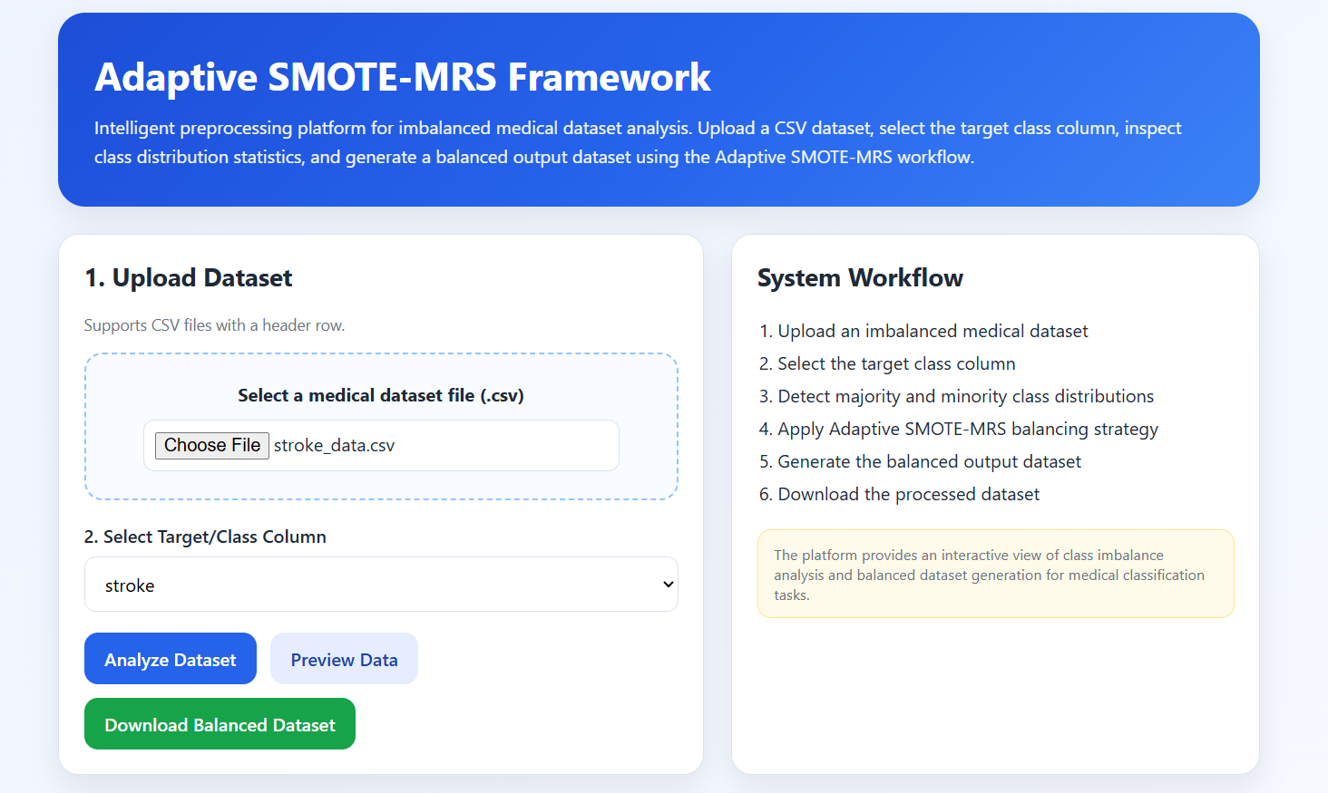

A.4 DATASET PREVIEW PAGE

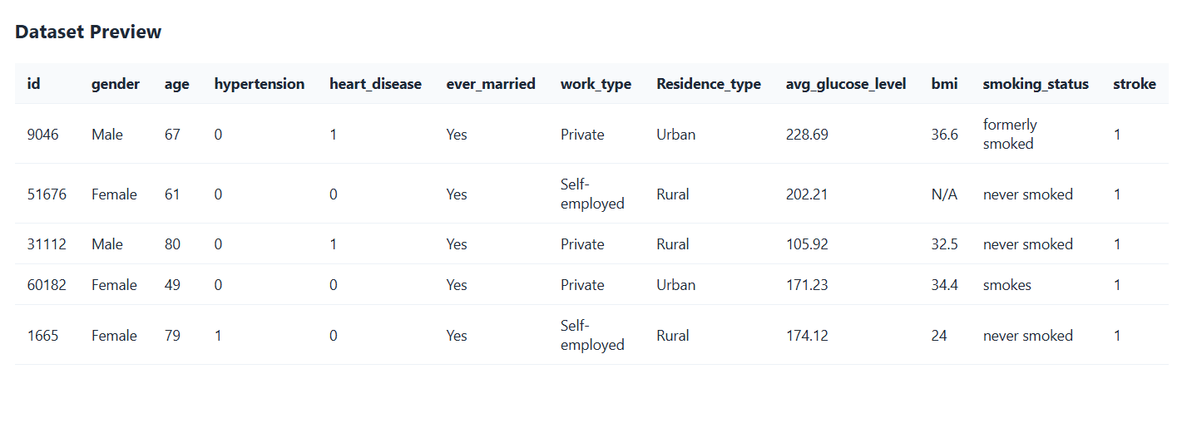

A.5 ANALYSIS DASHBOARD

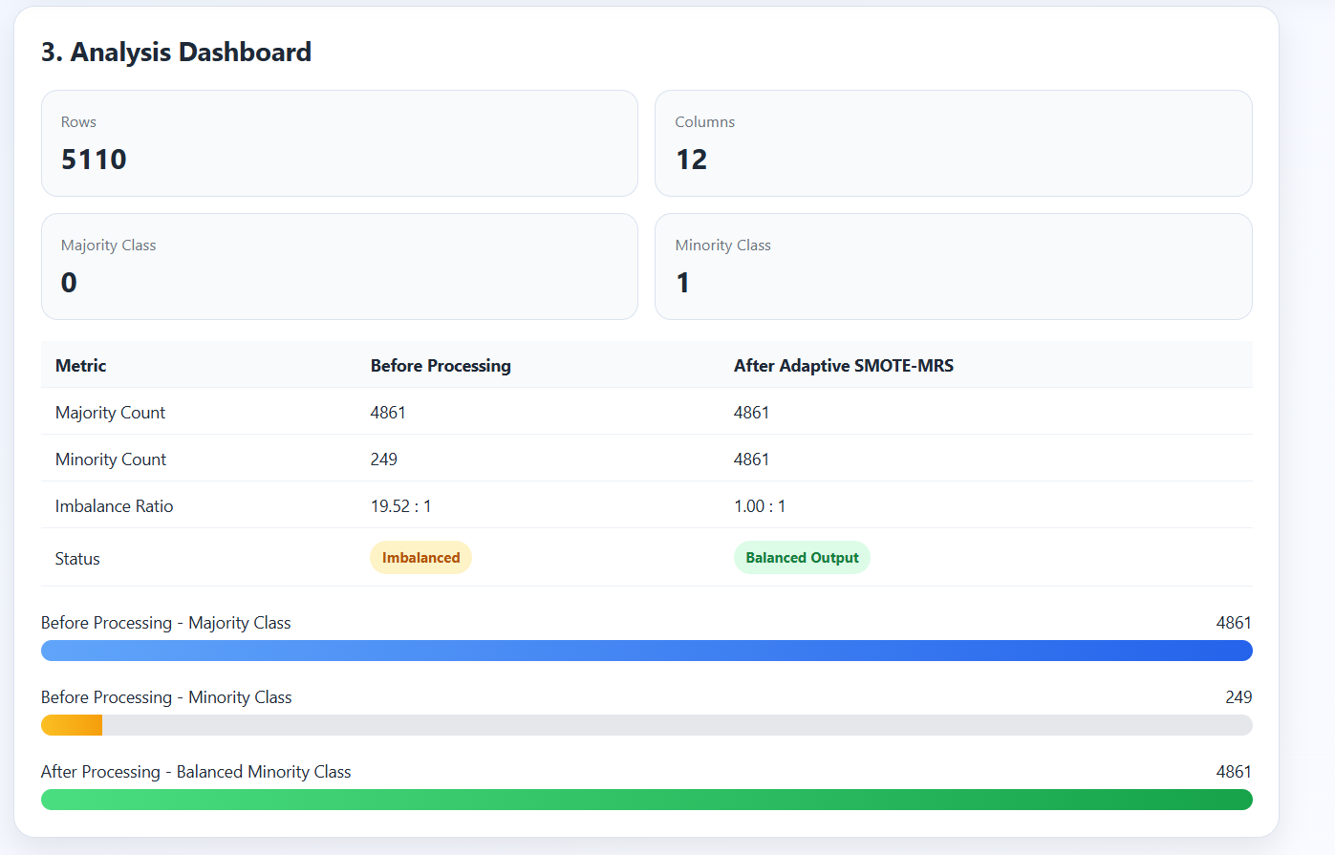

APPENDIX B: ABBREVIATION

Abbreviation | Full Form
ADASYN | Adaptive Synthetic Sampling
AUC | Area Under the ROC Curve
CKD | Chronic Kidney Disease
CV | Cross-Validation
GAN | Generative Adversarial Network
G-SMOTE | Geometric Synthetic Minority Over-sampling Technique
IR | Imbalance Ratio
KNN | K-Nearest Neighbors
LightGBM | Light Gradient Boosting Machine
ML | Machine Learning
MRS | Multi-Resolution Sampling
MWMOTE | Majority Weighted Minority Oversampling Technique
NB | Naive Bayes
RF | Random Forest
ROC | Receiver Operating Characteristic
ROS | Random Over-Sampling
SMOTE | Synthetic Minority Over-sampling Technique
SVM | Support Vector Machine
UCI | University of California Irvine
XGBoost | Extreme Gradient Boosting

